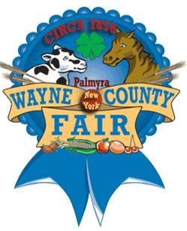

Wayne County Fair Apprentice for 2015
Taylor Scott

Being the Wayne County Fair apprentice was an amazing experience. It is also a great honor to be able to be the Wayne County Fair apprentice. To be the one that’s selected out of all the applicants is a great honor. Being the apprentice you have to work hard and be the best of your ability. It is an educational experience to work within all the different jobs that are performed to keep the fair operational and to have it all ready the week of the fair. You even get to experience the dirty aspect of the fair (meaning trash duty).
I was so happy that I applied for the apprentice position. All the different experiences were fun and full of information. Because I was able to be the Fair apprentice I’m NOT as nervous when I have to public speaking. I also was able to make new friends in college because I wasn’t as shy as I was before the fair. The fair representatives help me overcome most of my shyness up and made me more confident in myself. I also am more confident calling strangers on the phone and leaving a voice mail. The people at the Fair were wonderful people and they really are like a family and that’s really comforting and they were there for me if I needed anything.
Some advice I’d give you is make sure you are polite to everyone (that should be a given). Get the priest in advance for the opening ceremony because a lot of the priest either go on vacation or have their own event during the week of the fair. Make sure your time management is good before the fair make sure you have everything set up before the first day of the fair. I am thankful for the friends I made for a life time and am looking for to future, thank you to the entire Wayne County Fair Volunteers.

