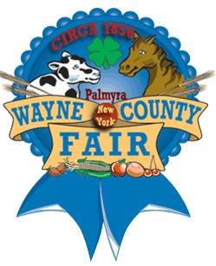

Wayne County Fair Apprentice for 2010
Kelsey Hamilton

Working as the Wayne County Fair Apprentice in the summer of 2010 was not a job but a career opportunity. The networking and communication skills I developed during this time have assisted me in my studies and career path. Not only has the task of the apprentice opened doors of opportunity for me, but it is an asset to my resume. The Wayne County Fair has had a huge influence on my life. I gained a greater understanding of the compassion, the efforts and the work done by many volunteers in order to put together one of the best County Fairs in New York State.

