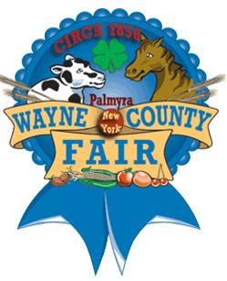

Wayne County Co-Fair Apprentice for 2013
Andrew C. Hamilton (Charlie)

I was the Wayne County Fair Apprentice in 2013. Hannah Williams and I worked together as the apprentice team. We had the opportunity to work with the Fair Board Members and the Fair Superintendents. We attended meetings, did public relations work and learned what a great deal of effort it takes to put a County Fair together. We participated in the fair competitions. We dressed a hay bale for the hay bale contest, helped out with the pie contest and the veggie race.
Working as a Fair Apprentice was a great experience. It has helped me as I move on into the future. I met people who encouraged me. It is a great experience for my resume. The networking and communication skills have helped me with my career. I currently work at Country Max and at Tripplet’s Machine Shop. I look back at my experience as an Apprentice and am Thankful for having had the great opportunity to work with the Wayne County Fair. It has had a big impact on my life.

