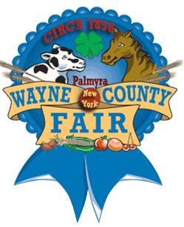

Wayne County Fair Apprentice for 2014
Abigail Miller

The Wayne County Fair offers an incredible opportunity for a junior or senior (boy or girl) in high school to become their Apprentice. As a former Apprentice I strongly urge you to try it out! Not only is it a fun and engaging experience, it is also a life changer! In the process you met a ton of new folks building your interactive skills; you will make surprising connections with people and Hey! It looks great on your resume. Public speaking is scary for anyone, but with practice and a wonderful support system, it’ll become a breeze! The people are amazing to work with and learn from, but most importantly your confidence level will sky rocket! You’re just a simple 300 word essay and an interview a way from this experience. You will not regret it!

